ESSER Brings a New Product Line to Security 2014

Neuss, 23 September 2014 - Besides its professional products in the fields of fire detection technology, voice alarms, and risk management, Esser presents its new Emergency Light Systems product line at the Security global trade fair for safety and fire protection, which complements its extensive portfolio.
From early reliable fire detection to efficient evacuation through utilization of the most modern communication media, all facets of modern professional fire protection become transparent to the visitor. The focus is on:

- Control of risk and alarm scenarios via innovative fire detection and control systems;
- Evacuation according to the multisensory principle, based on the anti-discrimination law;
- Active evacuation route control with evacuation route lighting products;
- Reliable early detection of fires in industrial environments;
- Connectivity of mobile end devices to the security systems;
- New design and solution concepts in the field of voice alarm, such as call stations with integrated display for additional information.

All aspects are represented through a variety of innovative products. These includes products such as ES Detect, a microprocessor-driven non-addressable fire alarm for conventional use; in addition to intelligent algorithms for early fire detection, it features integrated drift compensation, among other things. The operating time of the fire alarm prescribed by the DIN 14675 standard can be extended to 8 years, instead of the customary five! In combination with the small ES Line control unit, the highest level of fire protection is made possible specifically for smaller objects, such as kindergartens, offices, clinics, pharmacies, and comparable projects.

FAAST 8100E is an innovative aspiration system, which combines dual optical smoke detection by means of highly sophisticated algorithms with additional functionality for the prevention of false alarms.

The addressable Compact loop control panel meets all European standards of fire detection technology, and the proven user-friendly programming interface of tools 8000 contributes to its short commissioning period.

The new VARIODYN® D1 Comprio voice alarm system contains the full range of functionality of a professional voice alarm system according to the DIN EN 54-16 standard. This compact system is particularly suitable for application in small and medium-sized objects such as schools, hotels, supermarkets, and offices.
An interface with the fire alarm control panel can ensure that a building can be evacuated rapidly and effectively in the event of danger.

At the Security trade fair, interested visitors will have an opportunity to personally view the advantaged of these professional products and systems in Hall 3, Booth 211.

---------------------------------------------------------------------------------------------------------------
2935 characters (incl. spaces)

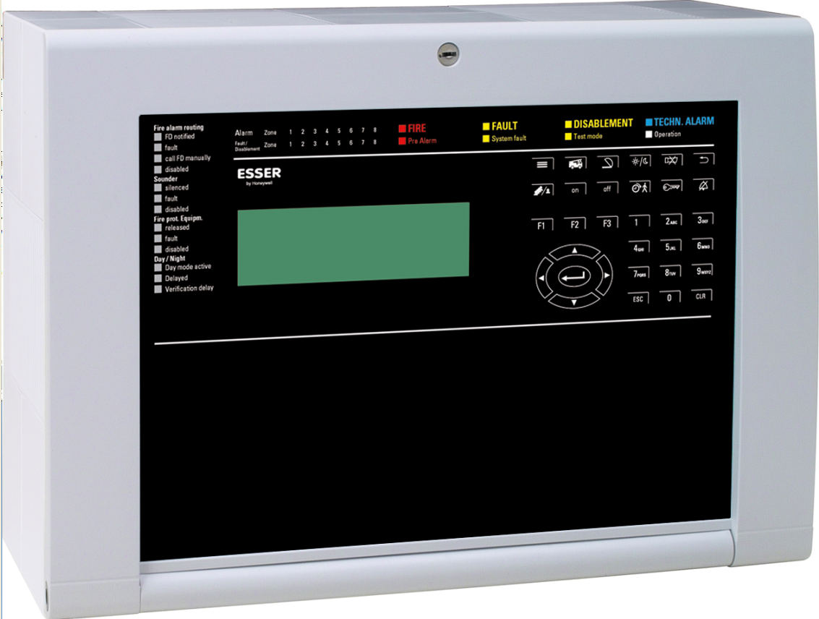
pictures:
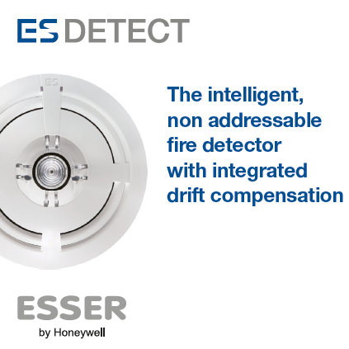

ES Detect - More than a detector Compact - fire alarm loop control panel

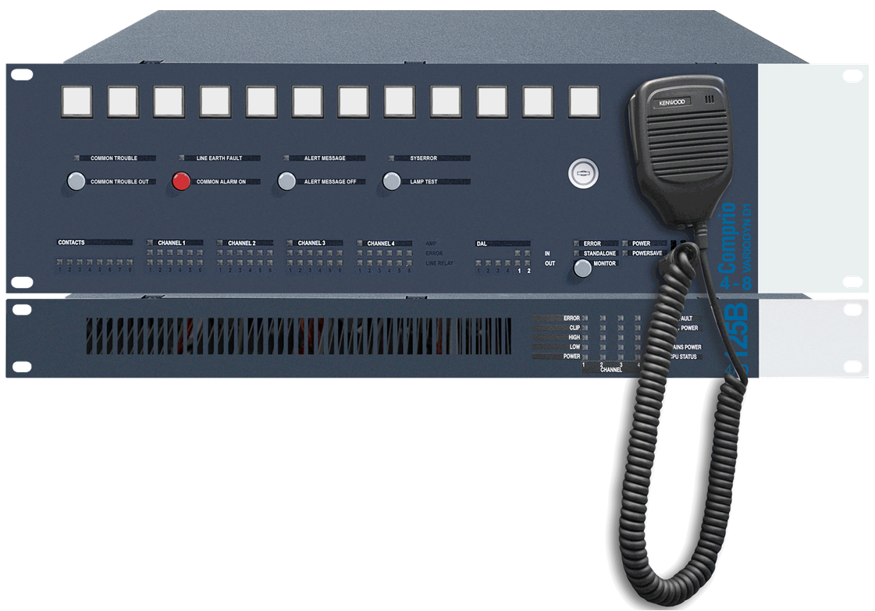
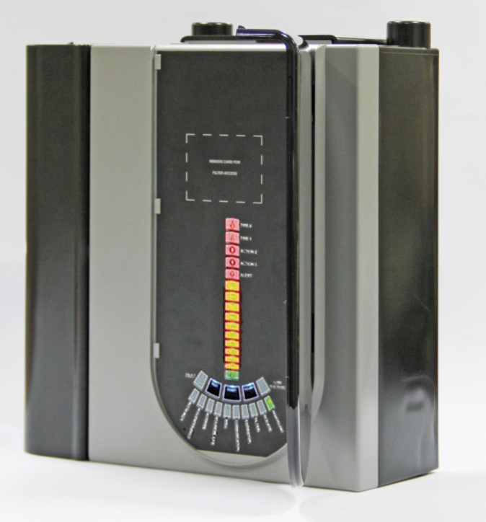

Comprio - designed for professional VA/PA FAAST – innovative aspiration system
Novar GmbH is part of Honeywell International and is highly regarded, with its long-established ESSER and Ackermann brands, as a leader in the field of fire detection technology, voice alarm and in the hospital and care communication.

Honeywell International is a diversified Fortune 100 company serving customers worldwide with aerospace products and services, control technologies for buildings (private and commercial), products for the automotive industry, and turbochargers as well as specialty materials. Honeywell operates within the EMEA region (Europe, Middle East and Africa) EMEA in over 35 countries and employs some 30,000 people there. Honeywell's shares are traded in the stock markets of New York, London and Chicago. For more information, please visit www.honeywellnow.com.

This release contains forward-looking statements as defined in Section 21E
of the Securities Exchange Act of 1934, including statements
about future business operations, financial performance and market conditions. Such forward-looking statements involve risks and uncertainties inherent in business forecasts as further described in our filings under the Securities Exchange Act.

--------------------------------------------------------------------------------------------------------------------------------
Contact data:

Mr. Manuel Pelazas
Novar GmbH a Honeywell Company
International Sales Support
+49 (0) 2131 / 40615479
manuel.pelazas@honeywell.com

