Innovative Fire Detection for Conventional Use -
ES Detect by ESSER

Neuss, 23 September 2014 - ES Detect is a microprocessor-driven non-addressable fire alarm for conventional use, which is setting new standards: in addition to intelligent algorithms for early fire detection, this innovative recipient of the GIT Award 2015 features integrated drift compensation. The operating time of the fire alarm prescribed by the DIN 14675 standard can be extended to 8 years, instead of the customary five!

ES Detect provides a wide range of different alarm systems, including the OTblue and O²T multisensor detectors, so that in the conventional use all the parameter advantages can be used even under difficult ambient conditions. The ES Detect also leaves conventional standard detectors behind in terms of ease of maintenance, since measurements, degrees of pollution, alarm counters, and operating hours can be read.

In combination with the small ES Line control unit, the highest level of fire protection is made possible specifically for smaller objects, such as kindergartens, offices, clinics, pharmacies, and comparable projects.

-------------------------------------------------------------------------------------------------------------------------------------------------
1300 characters (incl. spaces)

picture:
ES DETECT - Innovative Fire Detection for Conventional Use

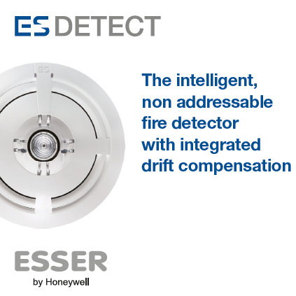

Novar GmbH is part of Honeywell International and is highly regarded, with its long-established ESSER and Ackermann brands, as a leader in the field of fire detection technology, voice alarm and in the hospital and care communication.

Honeywell International is a diversified Fortune 100 company serving customers worldwide with aerospace products and services, control technologies for buildings (private and commercial), products for the automotive industry, and turbochargers as well as specialty materials. Honeywell operates within the EMEA region (Europe, Middle East and Africa) EMEA in over 35 countries and employs some 30,000 people there. Honeywell's shares are traded in the stock markets of New York, London and Chicago. For more information, please visit www.honeywellnow.com.

This release contains forward-looking statements as defined in Section 21E
of the Securities Exchange Act of 1934, including statements
about future business operations, financial performance and market conditions. Such forward-looking statements involve risks and uncertainties inherent in business forecasts as further described in our filings under the Securities Exchange Act.

-------------------------------------------------------------------------------------------------------------------------------------------

Contact data:

Mr. Manuel Pelazas
Novar GmbH a Honeywell Company
International Sales Support
+49 (0) 2131 / 40615479
manuel.pelazas@honeywell.com

