ESSER expands its training offerings -
Videos strengthen understanding

Neuss, October 22, 2013 - Novar, manufacturer of high quality products of the long-standing ESSER brand, now supports its product training in the areas of fire detection technology, voice alarms and risk management systems with meaningful training films. The short videos serve to clarify particular content from the corresponding classroom training. As a supplement to the trainer's explanations, the videos are shown to the training participants as part of their corresponding activity to specifically address certain training topic contents.

The comprehensive training program is meaningfully expanded in this way. At the same time, understanding of selected aspects of the complex technology is effectively improved.
Currently, four of these training videos are available on the homepage www.esser-systems.com. Additional videos are already planned because of the good response.

Following management's move to a prestigious building near the previous headquarters, the enhanced training is performed on the new premises, because the previous capacity was no longer sufficient. There were 3,000 trainees in Neuss during the past year.

Telephone contact: Manuel Pelazas, International Sales Support +49 (0) 2131 / 40615479

Illustrations:
New premises for ESSER classroom training:

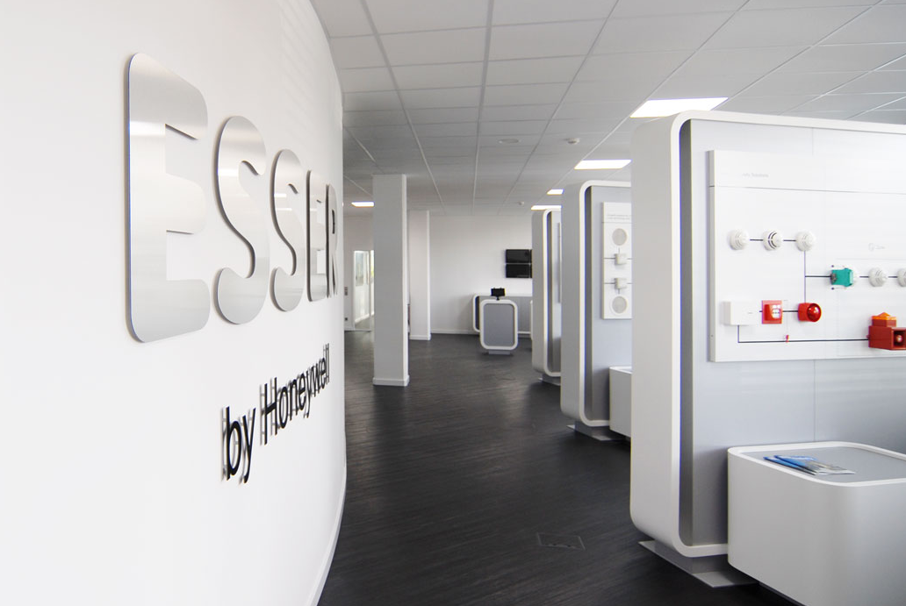

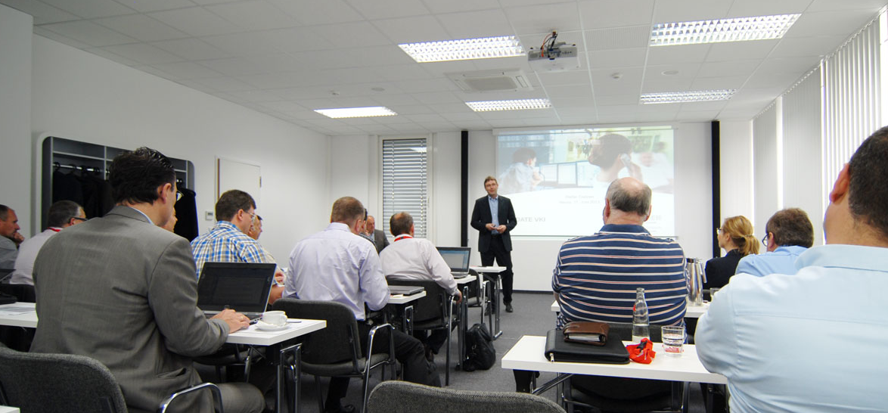
Novar GmbH is part of the Honeywell Life Safety business unit (HLS) and is highly regarded, with its long-established ESSER and Ackermann brands, as a leader in the field of fire detection technology, voice alarm and in the hospital and care communication.

HLS, with sales of 15.9 billion U.S. dollars, belongs to Automation and Control Solutions (ACS), one of four strategic business units within the Honeywell Group. HLS provides worldwide protection with its innovative products, people and assets, and is a leader in fire protection, communication systems, gas detection, and personal protective equipment, as well as in patient monitoring. The high quality products, integrated system solutions and services make life safer and more comfortable. HLS leading-edge technology is found everywhere in your immediate vicinity - in products, software and system solutions, such as in airports, hotels, hospitals, schools, business centers, and stadiums, as well as in industrial environments.

Honeywell International is a diversified Fortune 100 company serving customers worldwide with aerospace products and services, control technologies for buildings (private and commercial), products for the automotive industry, and turbochargers as well as specialty materials. Honeywell operates within the EMEA region (Europe, Middle East and Africa) EMEA in over 35 countries and employs some 30,000 people there. Honeywell's shares are traded in the stock markets of New York, London and Chicago. For more information, please visitwww.honeywellnow.com.

This release contains forward-looking statements as defined in Section 21E
of the Securities Exchange Act of 1934, including statements
about future business operations, financial performance and market conditions. Such forward-looking statements involve risks and uncertainties inherent in business forecasts as further described in our filings under the Securities Exchange Act.

