ESSER develops loop wiring technology for voice alarm systems -
High reliability and lower costs

Neuss, October 22, 2013 – Manufacturers of professional voice alarm systems and electro-acoustic emergency warning systems are currently working on loop wiring technology for 100 V loudspeaker connections. In contrast to fire detection technology, loop wiring technology has not yet been established as standard for voice alarm systems, because their higher powers have different requirements. The new VARIODYN D1 Loop Technology from ESSER is a large successful step forward here.
Complete system reliability for loudspeakers has still not yet been required in the relevant standards. If you assemble a standard system by today's state-of-the-art according to DIN VDE 0833-4 or EN 60849, an A/B or simple cabling in spur technology is sufficient, depending on the application.

They are mandatory for required voice alarm system building regulations in the respective federal states' guidelines for circuit systems. Thus, a 30-minute alarm must be guaranteed. VARIODYN D1 Loop Technology represents an alternative to E30 cabling, because here a loop is fed on both sides and ensured according to EN 54-17 approved loop isolator modules, so that functionality continues even during a short circuit. Based on these many advantages, we can assume that 100 V loop wiring system technology will emerge as the middle- to long-term standard.

Telephone contact: Manuel Pelazas, International Sales Support +49 (0) 2131 / 40615479

Illustration:
ESSER Loop Technology for 100 V loudspeaker connection

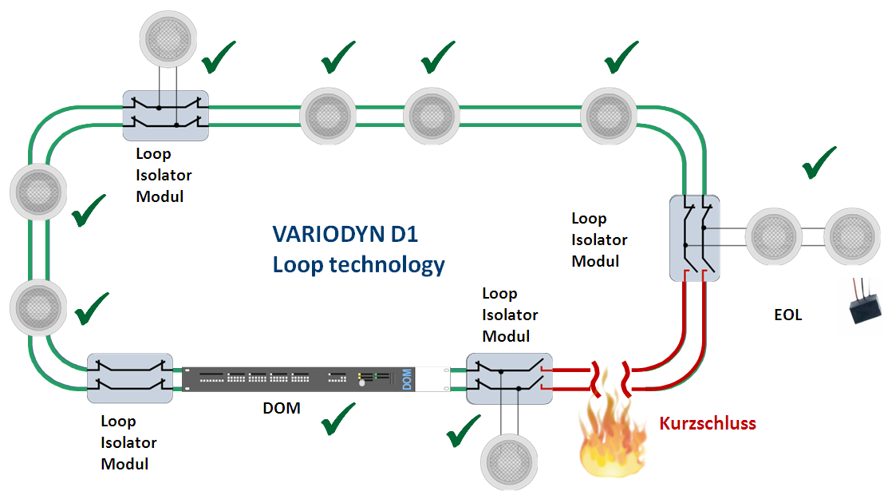

Novar GmbH is part of the Honeywell Life Safety business unit (HLS) and is highly regarded, with its long-established ESSER and Ackermann brands, as a leader in the field of fire detection technology, voice alarm and in the hospital and care communication.

HLS, with sales of 15.9 billion U.S. dollars, belongs to Automation and Control Solutions (ACS), one of four strategic business units within the Honeywell Group. HLS provides worldwide protection with its innovative products, people and assets, and is a leader in fire protection, communication systems, gas detection, and personal protective equipment, as well as in patient monitoring. The high quality products, integrated system solutions and services make life safer and more comfortable. HLS leading-edge technology is found everywhere in your immediate vicinity - in products, software and system solutions, such as in airports, hotels, hospitals, schools, business centers, and stadiums, as well as in industrial environments.

Honeywell International is a diversified Fortune 100 company serving customers worldwide with aerospace products and services, control technologies for buildings (private and commercial), products for the automotive industry, and turbochargers as well as specialty materials. Honeywell operates within the EMEA region (Europe, Middle East and Africa) EMEA in over 35 countries and employs some 30,000 people there. Honeywell's shares are traded in the stock markets of New York, London and Chicago. For more information, please visit www.honeywellnow.com.

This release contains forward-looking statements as defined in Section 21E
of the Securities Exchange Act of 1934, including statements
about future business operations, financial performance and market conditions. Such forward-looking statements involve risks and uncertainties inherent in business forecasts as further described in our filings under the Securities Exchange Act.

