Professional voice alarms for smaller premises -
Comprio from ESSER

Neuss, October 23, 2013 - The new voice alarm system VARIODYN® D1 Comprio includes all the functionality of a professional voice alarm system in accordance with DIN EN 54-16, including voice storage capability without additional hardware. The compact system is particularly suitable for small and medium-sized applications such as schools, hotels, supermarkets, offices and agencies.

Using a defined interface, the fire alarm control panel ensures that a building can be quickly and effectively evacuated in case of danger. Once an alarm is triggered, the fire alarm control panel automatically activates the voice alarm system that relays the voice messages stored there via loudspeakers to the affected parts of the building. Also, live announcements or situational announcements are thus possible directly through an emergency microphone. The alarm is always in the correct location, with no need for additional equipment. The building can be evacuated within a very short time, so that the fire department can directly begin with fire-fighting operations.

VARIODYN® D1 Comprio consists of the unit for control, announcement and operating functions, as well as the four- channel amplifier with battery charger. The advantage of this two-component system: With the battery charger in the amplifier, the entire system is supplied with emergency power during a power failure. This saves valuable space and cost, as an external emergency power supply is no longer required.

Telephone contact: Manuel Pelazas, International Sales Support +49 (0) 2131 / 40615479

Illustration:
VARIODYN ® D1 Comprio - Compact control from the ESSER brand for voice alarms in smaller premises

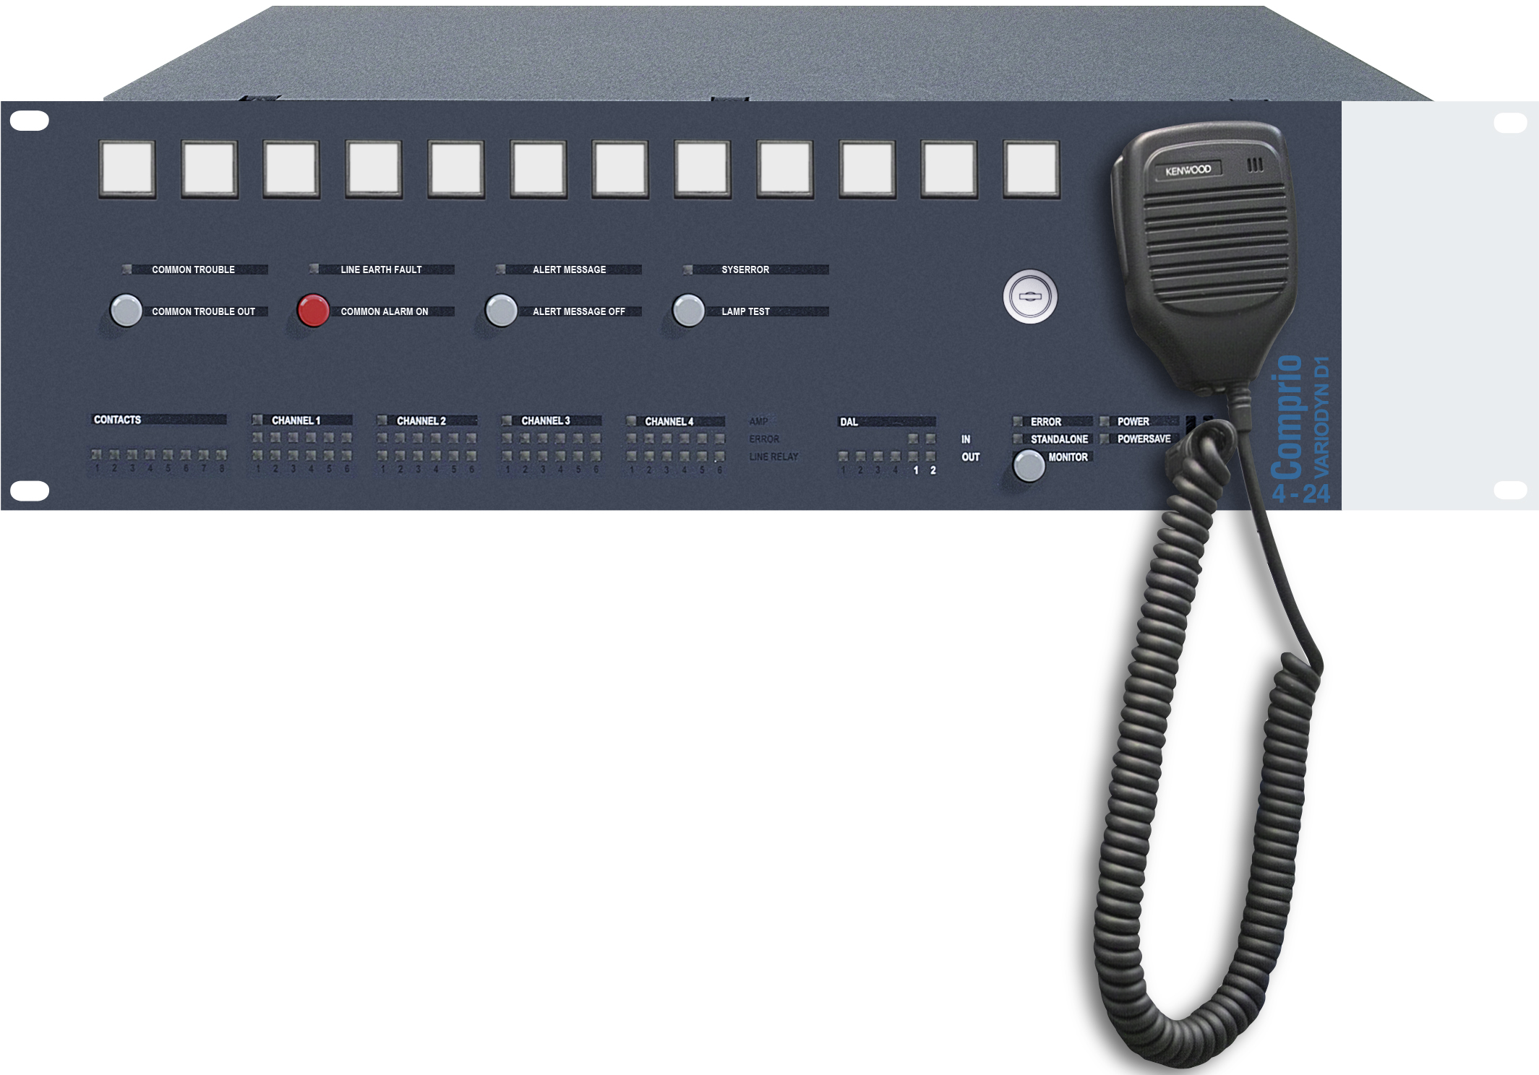

Novar GmbH is part of the Honeywell Life Safety business unit (HLS) and is highly regarded, with its long-established ESSER and Ackermann brands, as a leader in the field of fire detection technology, voice alarm and in the hospital and care communication.

HLS, with sales of 15.9 billion U.S. dollars, belongs to Automation and Control Solutions (ACS), one of four strategic business units within the Honeywell Group. HLS provides worldwide protection with its innovative products, people and assets, and is a leader in fire protection, communication systems, gas detection, and personal protective equipment, as well as in patient monitoring. The high quality products, integrated system solutions and services make life safer and more comfortable. HLS leading-edge technology is found everywhere in your immediate vicinity - in products, software and system solutions, such as in airports, hotels, hospitals, schools, business centers, and stadiums, as well as in industrial environments.

Honeywell International is a diversified Fortune 100 company serving customers worldwide with aerospace products and services, control technologies for buildings (private and commercial), products for the automotive industry, and turbochargers as well as specialty materials. Honeywell operates within the EMEA region (Europe, Middle East and Africa) EMEA in over 35 countries and employs some 30,000 people there. Honeywell's shares are traded in the stock markets of New York, London and Chicago. For more information, please visit www.honeywellnow.com.

This release contains forward-looking statements as defined in Section 21E
of the Securities Exchange Act of 1934, including statements
about future business operations, financial performance and market conditions. Such forward-looking statements involve risks and uncertainties inherent in business forecasts as further described in our filings under the Securities Exchange Act.

