Esser by Honeywell portfolio were well received during nationwide road show in Sweden and Brazil

The Esser by Honeywell recently completed a nationwide road show from May 23 to 26, 2011 in Sweden to promote Honeywell as one of the leading fire suppliers in the Nordics. More than 70 selected high potential Value Adding Retailers (VARs), planners, consultants, authorized experts and also important industrial end customers attended the road show events in Uppsala, Gothenburg and Malmø. Attendees learned everything about professional multi-sensor technology and our IQ8Quad detector range. Manuel Pelazas, International Sales Support Manager for Western Europe, Latin America and Middle East & Africa, supported the Swedish team and explained how the fire test procedure which is compliant to the European Standard EN54 has become a real reference value for smoke detection. He also explained how the false alarm resistant multi-sensor detectors O²T, OT^{blue} and OTG increase the customers’ perception of an extremely reliable fire alarm system.

Two months later – precisely from July 24 to 29, 2011 the Esser road show proceeded to Brazil and stopped over in Sao Paulo, Belo Horizonte and Rio de Janeiro, overall 195 decision makers followed the invitation and attended the presentations by Manuel Pelazas, who is a native of Spain, about the innovative product portfolio of one of the European market leaders for fire alarm solutions with great interest.

Practice-oriented demonstration by experienceable evacuation scenarios

The competent presentation of the most current fire alarm technology by the International Sales Support Manager, contributed crucially to the success of the road show on this side of and beyond the Atlantic. The focus was appropriate in both countries on the multi-sensor technology with the IQ8Quad product family - in particular O²T (a smoke detector with second detection angle), OT^{blue} (a smoke detector with blue LED for quick-responding) and OTG (a smoke detector with integrated gas cell for additional detection of carbon monoxide), and on the new milestone in the development of the technical fire protection: the FACP (fire alarm control panel) FlexES control.

The Brazilian and Swedish audience was treated to live demonstrations of the innovative and integrated solutions designed in Germany. The addressable and intrinsically safe detector for hazardous areas was given particular attention, amongst others for the application in the industrial field. The presentation of the IQ8Quad detector with integrated alarm devices (smoke detection & sound & flash & speech) and the equivalent solution without detection called IQ8Alarm demonstrated the difference in a human crowd’s behavior when hearing a conventional fire alarm sounder versus a fire alarm supported via voice messages and underline the significant positive effect on evacuation effectiveness. In addition to being highly effective, the system features reduces installation cost, wiring, power supply units and maintenance due to powered loop technology. Last but not least, ESSER provided a prospect on the interesting option of the new multifunctional loop FlexES com that offers the opportunity to implement live spoken dedicated messages, freeze image, live video as well as other versatile applications on the same loop.

The opinion of the audience (coming from the road show surveys) has been very positive.

In particular, the event for new customers was challenging, because it was for many the first time to attend a presentation regarding the performance of multisensor detectors. Therefore the R&D from Esser developed a demo-tube for live presentation, to demonstrate how the IQ8Quad smoke detector works and recognizes smoke and disturbance variables e.g. steam. This way the technical reliability of the detector could be demonstrated best.

The announcement that next year’s road show is about all new features and functions in FlexES resonated with the audience and generated a tremendous amount of interest: customers are already looking forward to the road show next year!

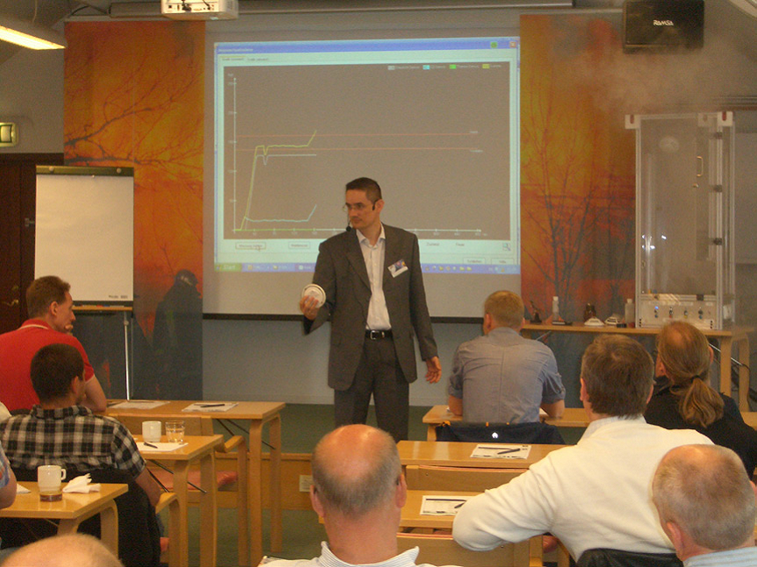
Photo Name: Road show Sweden 2011
Photo Caption: Manuel Pelazas, International Sales Support Esser by Honeywell, presents IQ8Quad detector range to Swedish customers

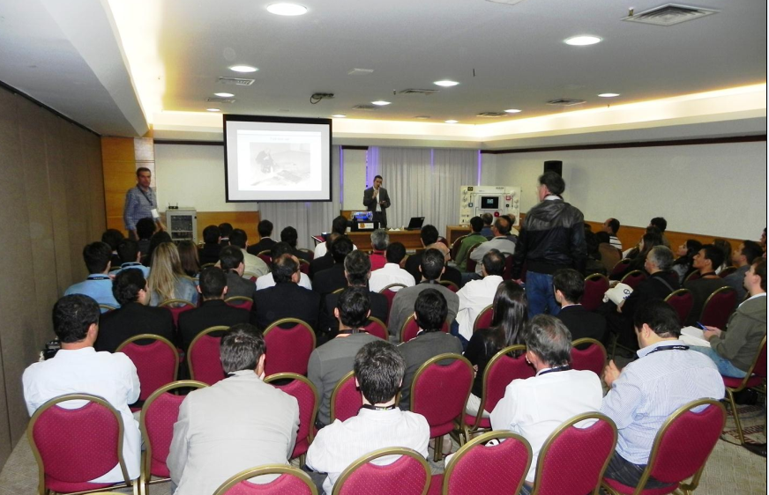
Photo Name: Road show Brazil 2011
Photo Caption: Manuel Pelazas, International Sales Support Esser by Honeywell, presents IQ8Quad detector range to Brazilian customers

(4417 characters including spaces)

Honeywell International (www.honeywell.com) is a Fortune 100 diversified technology and manufacturing leader, serving customers worldwide with aerospace products and services; control technologies for buildings, homes and industry; automotive products; turbochargers; and specialty materials. Based in Morris Township, N.J., Honeywell’s shares are traded on the New York, London, and Chicago Stock Exchanges. For more news and information on Honeywell, please visit www.honeywellnow.com.
This release contains certain statements that may be deemed “forward-looking statements” within the meaning of Section 21E of the Securities Exchange Act of 1934. All statements, other than statements of historical fact, that address activities, events or developments that we or our management intends, expects, projects, believes or anticipates will or may occur in the future are forward-looking statements. Such statements are based upon certain assumptions and assessments made by our management in light of their experience and their perception of historical trends, current economic and industry conditions, expected future developments and other factors they believe to be appropriate. The forward-looking statements included in this release are also subject to a number of material risks and uncertainties, including but not limited to economic, competitive, governmental, and technological factors affecting our operations, markets, products, services and prices. Such forward-looking statements are not guarantees of future performance, and actual results, developments and business decisions may differ from those envisaged by such forward-looking statements.

Telephone contact: International Sales Support, Mr. Manuel Pelazas, +49 (0) 21 37/17-479

Please note:
Text files and specifications can be downloaded at www.esser-systems.com.

